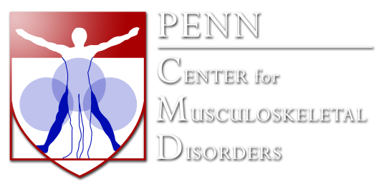
Histology Core Service Request Form Please Fill Out Applicable Info
Email to Dr Edgardo Arroyo and arrange sample drop off: arroyoe@pennmedicine.upenn.edu
Name: ___________________________ Email: _________________________________
B.A./Grants Manager Name: ____________________ Email: ________________________________
Project Description (1-2 sentences describing scientific goals - required unless paraffin processing only):
______________________________________________________________________________________
______________________________________________________________________________________
Species: ___________________ Tissue: _______________ P.I.: __________________________________
P.I. Email: ______________________________ Drop-Off Date: _________ Date Needed: _________
*Samples for Paraffin Processing must be fixed e.g. in formalin, decalcified (if desired), rinsed, put in 70%EtOH prior to drop off
Paraffin
Processing (Tissue Processor)
☐ Yes # of samples: ______
Processor Cycle (if known) : ______
*If unknown consult the Core first*
Embedding: Sectioning:
☐ Yes ☐ Yes [Complete Adjacent Table]
Staining: ☐ Yes [Complete Adjacent Table]

Sectioning & Staining
Sample No. | Section Thickness (um) | # of sections per slide | # of Slides | Stain Type  [if desired]

Frozen
Embedding: Sectioning:
☐ Yes ☐ Yes [Complete Adjacent Table]
Staining: ☐ Yes [Complete Adjacent Table]

Plastic Embedding:
☐ Yes # of samples: ______
Sectioning: ☐ Yes [Complete Adjacent Table]
Staining: ☐ Yes [Complete Adjacent Table]

Slide Scanning (bright field) ☐ Yes
# of slides: ______ Objective ☐ x10 ☐ x20

Additional Instructions:

*Please contact Edgardo Arroyo with any questions: arroyoe@pennmedicine.upenn.edu - Stemmler 350*
Note: Project requests require PI approval before any completion of service
Project Estimate: ________________ PI Signature: _____________________________

